### **Public Transportation Optimization**

### **Introduction:**

Transportation systems benefit greatly from real-time data analysis, allowing operators to optimize routes, monitor ridership, and improve overall service quality. IoT sensors play a crucial role in collecting this data. In this project, we'll create a Python script to collect location and ridership data from IoT sensors and send it to a transit information platform for analysis.

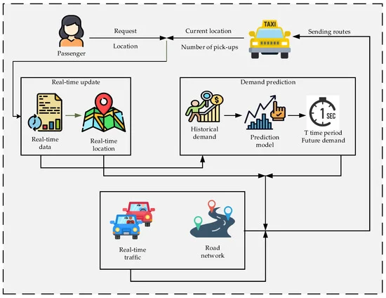

**Python Script:**

Develop a Python script to read data from the sensors, format it, and send it to the transit platform.

**Program:**

import requests

import time

import sensor_library # Replace with the actual library for your sensors

# Define the API endpoint of the transit information platform

API_URL = "https://yourtransitplatform.com/api/data"

# Initialize the sensors (replace with your sensor setup code)

sensor = sensor_library.initialize_sensor()

while True:

try:

# Read sensor data

location_data = sensor_library.read_location_data(sensor)

ridership_data = sensor_library.read_ridership_data(sensor)

# Create a data payload

data = {

"location": location_data,

"ridership": ridership_data

}

# Send data to the transit information platform

response = requests.post(API_URL, json=data)

if response.status_code == 200:

print("Data sent successfully")

else:

print("Failed to send data. Status code:", response.status_code)

# Wait for some time before sending the next data (adjust the interval as needed)

time.sleep(60) # Send data every 60 seconds

except Exception as e:

print("Error:", str(e))

**Key Components:**

**IoT Sensors**:

* Choose the appropriate sensors to collect data. For location data, you can use GPS modules, and for ridership data, consider weight sensors, RFID readers, or infrared sensors.
* IoT Device: Connect the sensors to a microcontroller or IoT device such as a Raspberry Pi, Arduino, or ESP8266/ESP32.

Transit Information Platform: Identify or set up the platform where data will be sent. It could be a cloud-based server, a custom database, or an existing transit information system.

**Steps Involved:**

* Select Sensors: Choose sensors capable of capturing location and ridership data accurately.
* Hardware Setup: Connect the selected sensors to your IoT device. Ensure that the device has internet connectivity.
* Choose a Platform: Decide where you want to send the data. This could be an existing transit management system or a custom server.
* Python Script Development:
  + **Data Collection:** Write code to gather data from the sensors, ensuring that it's accurate and in a usable format.
  + **Data Processing:** Format the collected data so that it can be easily interpreted by the transit information platform.
  + **Data Transmission:** Develop the script to send the data to the platform using HTTP requests or another suitable protocol. Ensure data security and integrity.
  + **Error Handling:** Implement robust error handling to manage scenarios such as connectivity issues or sensor failures.
  + **Data Logging:** Keep a local log of the data sent to the platform, which can be useful for debugging and auditing.
  + **Scheduling:** Set up a schedule for data transmission, typically at regular intervals, to keep the data up-to-date.

**Testing and Deployment:**

Test the script with actual sensor data and deploy it on the IoT device.

**Security:**

If sensitive data is involved, ensure that data transmission is secure. You may need to implement encryption and authentication.

**Monitoring and Maintenance:**

Continuously monitor the script's performance and data accuracy. Implement maintenance routines to address hardware or software issues.

**Scalability:**

If your transit system expands, make sure the script and platform can handle the increased data load.